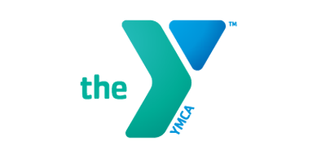

Private Swim Lessons
Adult/Child
Whether you are just starting out or are an experienced swimmer, our instructors will design an individual program and critique your skills to help motivate and achieve your swimming goals!
Individual (one person) | Members | Non-Members
30 Minute Private Lesson | $50 | $65
Package of 5-30 Minute lessons | $200 | $250
Package of 5 – 45 minute lessons | $225 | $275

Semi-Private (2 persons) | Members | Non-Members
30 Minute Private Lesson | $80 | $95
Package of 5-30 Minute lessons | $350 | $400
Package of 5–45 minute lessons | $375 | $425

Please fill out this form and return to the front desk with payment. If you have any questions or need more information, please contact Laurie Houseknecht, Aquatics Director at lhouseknecht@regionalymca.org. Payments MUST be made at time of registration. Lessons will be scheduled within a week’s time once received by the Aquatics Department.

Name: ___________________________________________________ Age: ________________DOB: ___________________
Parents Name: ___________________________________________________ Phone: _____________________________
Email: ____________________________________________________________________________________________________
Instructor Preference (If Known):_____________________________________________________________________
Please list all your available days/times: ____________________________________________________________
Payment: ________________________________________________________________________________________________
PLEASE NOTE: If you need to cancel a lesson, you must provide 24 hour notice directly to your swim instructor, otherwise you will be charged for the missed lesson. No refunds available.

