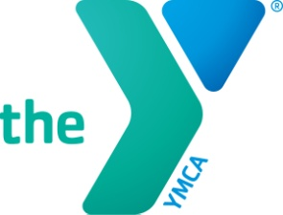
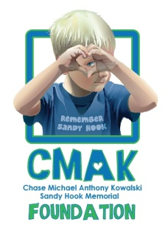
Race 4 Chase
Triathlon Program Application
Race 4 Chase is named for Chase Kowalski, an amazing little boy from Newtown, who loved to run. Race 4 Chase strives to empower kids to reach their full potential.
Registration is for children ages 6-12 years old wishing to participate in the Race 4 Chase Triathlon Program. This program provides youth with a fun, skill building, life-changing experience by introducing them to the sport of triathlon.
This free program runs for 5 weeks beginning Monday, June 28, 2021 and ending Saturday, July 31, 2021. Program times are 9:30 a.m. – 12:30 p.m. daily, Monday – Friday. Race day is the culmination of the program for the YMCA Race 4 Chase programs at YMCA Camp Sloper in Southington (1000 East Street, Southington CT) on Saturday, July 31, 2021 (Rain date August 1, 2021). All participants will compete in a Youth Triathlon on this day.
This application needs to be completed by both parent/guardian and child wishing to participate in the program. Please answer all questions; if you have additional children, each child must have a separate application.
Due to limited enrollment, applications will go through a lottery system. You will be notified if your child has been selected into the program by May 6, 2021. If selected, completion of a registration packet is required.
Deadline applications are due back no later than April 28, 2021
No extensions will be considered.

Race4Chase funding made possible by the
Chase Michael Anthony Kowalski Foundation
Parent section:
Childs Name _________________________ Birth Date ___/___/___ Sex (M/F) _____
Address _____________________________ City _________________ Zip ________
Parents Name ______________________________ Cell phone #_________________
Email ____________________________________ Home phone #________________
Honestly respond to the following questions so your child’s needs can be fairly evaluated. Please describe your child’s activity level and frequency:
___________________________________________________________________________________________________________________ __________________________________________________________________
What is your child’s swimming ability (please check)
________ Beginner ________ Intermediate ________ Advanced
What is your child’s biking ability (please check)
________ Beginner ________ Intermediate ________ Advanced
How would you describe your child’s overall heath?
__________________________________________________________________________________________________________________
What are your child’s favorite activities?
__________________________________________________________________________________________________________________
How will your child benefit from participating in this program?
__________________________________________________________________________________________________________________ _________________________________________________________________
Child’s section to answer. Parents can help write and spell if needed.
Why do you want to participate in the Race 4 Chase program?
____________________________________________________________________
_______________________________________________________________________________________________________________________
What do you like to do for fun?
__________________________________________________________________

